|  |  |  |
| --- | --- | --- |
| **LAB 321 Assignment** | **Type:** | **Long Assignment** |
| **Code:** | **J3.L.P0014** |
| **LOC:** | **600** |
| **Slot(s):** | **15** |

**Title:** Trekking & Hiking blog

**Background**

Hiking is the preferred term, in [Canada](https://en.wikipedia.org/wiki/Canada) and the [United States](https://en.wikipedia.org/wiki/United_States), for a long, vigorous walk, usually on [trails](https://en.wikipedia.org/wiki/Trails) ([footpaths](https://en.wikipedia.org/wiki/Footpaths)), in the countryside, while the word [walking](https://en.wikipedia.org/wiki/Walking) is used for shorter, particularly [urban](https://en.wikipedia.org/wiki/Urban_area) walks.

Complete this assignment to know how to record all your memory about your favorites hiking

Reference site: <http://us-123hiking.simplesite.com/>

**Program Specifications**

Program a web site to share your memory about trekking & hiking to everyone, detail functions of this website is described below

**Features:**

This website contains 4 main functions

* Function 1 : Home page : ( see PIC 01)
  + Display introduction entry and 3 main entries of : diary, photo and trekking link
  + Each entry contains
    - Entry name
    - Description picture
    - Entry description
* Function 2 : Diary( PIC 02)
  + List all diary entries
* Function 3 : Photo album ( PIC 03)
  + Display photo
* Function 4 : ( Useful link- PIC 04 )
  + List all helpful url for every one

You do not need to write interface for admin control panel, you can add data manually (use SQL SERVER Management studio).

Note: All data must be load from database, not hard code in page.

***Expectation of User interface:***

Pic 01 : Home Page

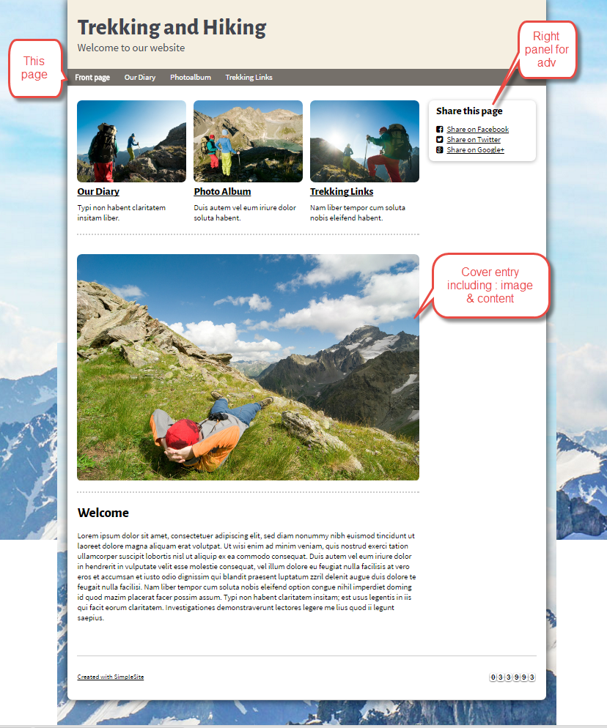

PIC 2 : My diary

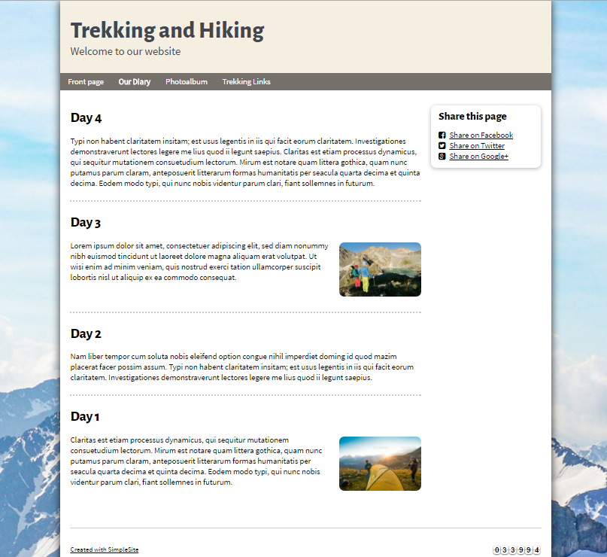

PIC 3 : Photo album

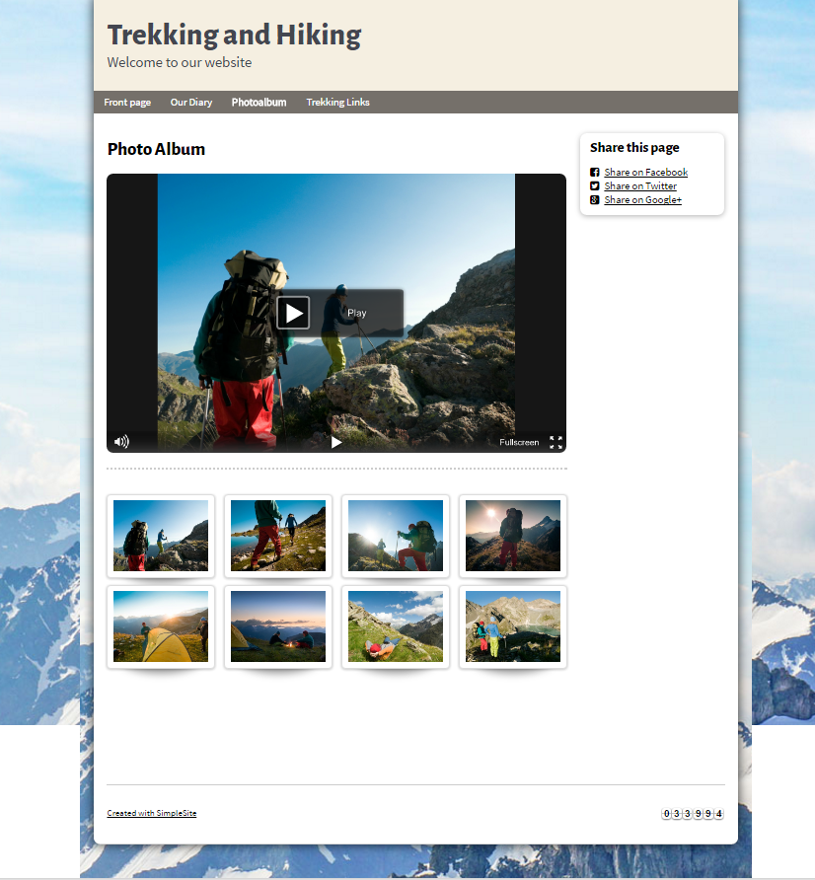

PIC 4 : list of useful link about hiking

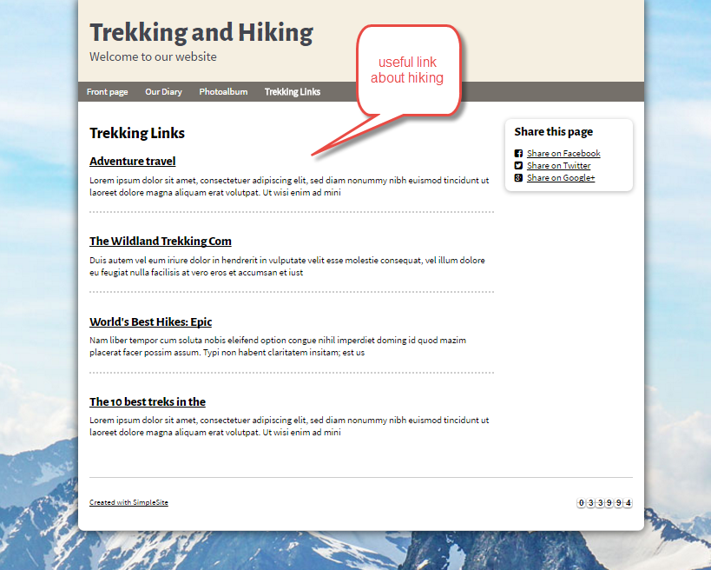

**Guidelines**

* Step 1 : Create web layout
* Step 2 : Create prototype
* Step 3 : Design database base on created prototype
* Step 4 : Code & Test